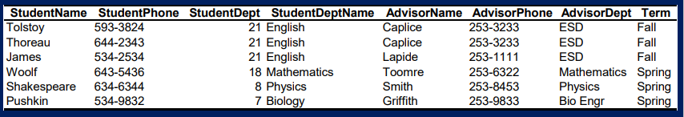

**Sample Solution:**

**FDs:**

StudentName - > StudentPhone

StudentName - > StudentDept

StudentName - > StudentDeptName

AdvisorName - > AdvisorPhone

AdvisorName - > AdvisorDept

Primary Key identified -> PK(StudentName, AdvisorName)

2NF: Removing Partial Dependencies

New tables:

|  |  |  |  |
| --- | --- | --- | --- |
| **StudentName** | StudentPhone | StudentDept | StudentDeptName |

|  |  |  |
| --- | --- | --- |
| **AdvisorName** | AdvisorPhone | AdvisorDept |

|  |  |  |
| --- | --- | --- |
| **StudentName** | **AdvisorName** | **Term** |

3NF: Removing Transitive Dependencies

StudentDept -> StudentDeptName

New tables:

|  |  |  |
| --- | --- | --- |
| **StudentName** | StudentPhone | StudentDept |

|  |  |  |
| --- | --- | --- |
| **AdvisorName** | AdvisorPhone | AdvisorDept |

|  |  |  |
| --- | --- | --- |
| **StudentName** | **AdvisorName** | **Term** |

|  |  |
| --- | --- |
| **DeptNumber** | DeptName |